
ANTONINE UNIVERSITY

Faculty of Engineering
Department of Technology in Computer Science

Subject

Computer Science internship report

Carried out by | Elie Estephan, 202410877  Technology in Computer Science Student
Host Company | Statometry

ACKNOWLEDGMENTS

I’m truly thankful for Antonine University, specifically the Department of Technology in Computer Science. I want to extend a special thanks to the head of department whose continuous encouragement and support pushed me to apply for my internship at every chance.

I really appreciate the trust that Statometry has put in me. Special thanks to my supervisor, Mr.Joe Estephan, who provided continuous assistance, guidance, and support throughout this journey of holding key responsibilities and providing solutions to real world practices in data science and analytics allowing me to translate academic theory into industry practice.

ABSTRACT

This project details the internship that took place at Statometry between June 9, 2026 and August 9, 2026.The main objective of this internship was to create and implement a well-designed data driven Customer Satisfaction Gap Analysis and Simulation application business companies understand what drives the overall customer satisfaction of their brand and which of their processes require improvement.

It starts with uploading SPSS survey data, data preview, running the gap analysis, simulate several scenarios for further brand improvement, and visualize general statistical analysis.

This app was built using Python (Flask), pandas, and scikit-learn, it preprocesses responses through validation, missing-data handling, and triple-mean imputation, then performs Multiple Linear Regression (MLR) to estimate statement importance/impact relative to overall customer satisfaction. Moreover, with the help of rest-inspired JSON APIs for asynchronous client-server communication, the frond end of this application is able to communicate with the backend and I was able to develop this app in its

This internship help me a lot in terms of constructing my workflow before even starting in order to have a clear vision of what’s coming as this app had some complex and challenging tasks and needed some essential statistical/Data analytical assistance.

This tool can be a major contributor to Statometry’s work as it may be proposed to its clients who work in customer satisfaction analysis and public opinion.
Table OF CONTENTS
ACKNOWLEDGMENTS 2
ABSTRACT 3
INTRODUCTION 5
CHAPTER 1 : COMPANY PRESENTATION 45
1. INTRODUCTION 2
2. Host ORGANIZATION 2
3. INTERNAL REGULATIONS 4
4. ROLE WITHIN TEAM 4
5. SUMMARY 5
Chapter 2 : OBSERVATIONS AND TASKS ACCOMPLISHED 6
1. INTRODUCTION 6
2. xxxxx 6
2.1. xxx 6
3. xx 24
3.1. xxxx 42
4. SUMMARY 42
CHAPITRE 3 : Internship EVALUATION 43
1. INTRODUCTION 43
2. EVALUATION OF THE WORK
3. CHALLENGES ENCOUNTERED 44
4. EVALUATION OF THE WORKING ENVIRONMENT 44
5. EVALUATION OF APPLIED KNOWLEDGE 44
6. SUMMARY 45
CONCLUSION 46
TABLE OF TABLES 47
TABLE OF IMAGES 47
LIST OF ABBREVIATIONS 48

INTRODUCTION

This internship that I have completed was carried out at Statometry, a company that focuses mainly on data analytics and market research and it provides statistical and analytical solutions worldwide. The main goal of this internship was to build and design a Customer Satisfaction Gap Analyzer; a web application that helps businesses understand what drives the overall customer satisfaction of their brand and which of their processes require a need for some improvements.

Through this internship, and by building and developing this flask web application, analysts may benefit from using this app by uploading their SPSS survey raw data and visualize their gap analysis on this data through running a multiple linear regression model; in addition to working with a simulation engine that helps prioritize some of their business processes on others.

As a computer science student in Antonine University; during this internship, I have gained a high level of experience in handling real-world examples/exercises involving data analytics and statistical modeling by connecting my AI/Machine learning, high level programming, and UX/UI skills.

CHAPTER 1: COMPANY PRESENTATION
- INTRODUCTION
As we proceed, Statometry will be presented briefly such as its role as a host organization for this internship, its internal rules and regulations and my main role there within the beloved team.

- HOST ORGANIZATION
Statometry is a data science company based in Badaro Beirut - Lebanon since 2017.Its a company specialized in research analytics and applied statistical and predictive modeling .It provides operational and predictive analytical solutions integrating both qualitative and quantitative data with high levels of experience.

- INTERNAL REGULATIONS
Very flexible working days and hours: I was able to work in a flexible time interval which was perfect.

Writing reports and attending in-person/online meetings at the end of every week were mandatory since my supervisor had to evaluate my work and provide some feedback which was very helpful and was taken into account. In addition, most of the time, my supervisor was active and ready for any potential help.

The final product including the source code, datasets, and the UX/UI of my application is confidential and private as it might be a potential product/tool to be proposed to Statometry’s clients/agencies it works with.

- ROLE WITHIN TEAM
My role within the team was to develop and produce a tool that might have been a solution or extension to one of their products.

My tasks involved working mainly on this interactive application with full statistical assistance from my supervisor, report to him on weekly bases, and make the necessary adjustments after receiving his feedback. Besides this app, I was also handed another task involving creating an AI agent (SLM) that is specialized to respond to data analytical requests.

- SUMMARY
I felt extremely comfortable as an intern in this company as the team was very responsible and responsive. In addition, feedback that was given according to my work every week was very helpful since I was able to know my mistakes in order to show significant improvement, provide better solutions, and learn from my mistakes .Lastly, I was told to drop all technical words while developing this UX/UI of this application due to the fact that the potential users of this app are either researchers, analysts, or project managers.
Chapter 2: OBSERVATIONS AND TASKS ACCOMPLISHED
1. INTRODUCTION
Through this internship, a very user friendly web application was designed in order to analyze customer satisfaction on business processes and to know where the brand is failing and which processes need further improvement. This app includes several essential functionalities from uploading an spss/xlsx file including raw survey data to being able to visualize a very comprehensive quadrant analysis of all the process attributes of any business. But mainly, this app is designed in order for any analyst/researcher/business owner to simulate several combinations of process statement performance scores and see how they would influence the overall satisfaction of the brand. They could also set any value for the overall satisfaction score for the brand and let this system find all possible combinations or even the optimal one for their process performance/satisfaction scores. Proceeding, all the tasks that I have worked on will be covered and explained in details.
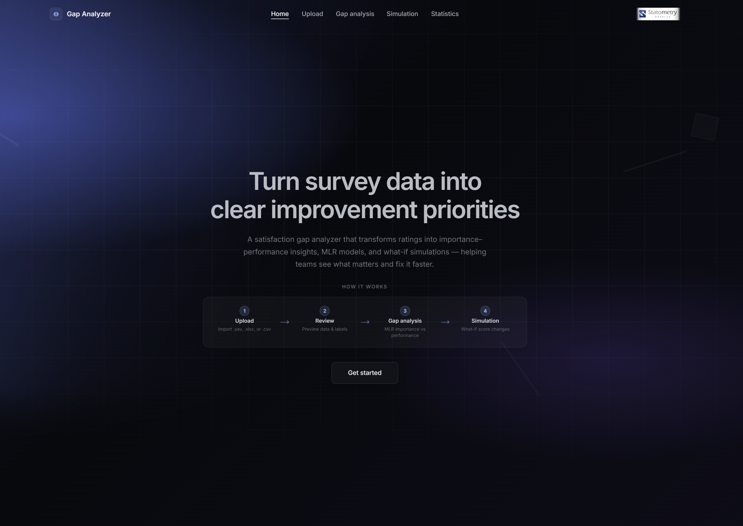
2. DATA UPLOAD,PREVIEW,AND PREPARATION (Quadrilx)
2.1
- Its start from the user’s side where they have to select a file for analysis (after naming their variables according to a certain specified regex), then system automatically detects each independent variable through its’ naming (SnQr) where n is the block/section number holding a set of independent variables and r is the variable number in addition to the overall satisfaction variable (dependent variable) that should also be included in the. That mainly depends on the user/clients questionnaire.
- After that, a data preview section would appear so that the user could visualize their data before data preprocessing. I have implemented validation messages so that we can make sure that if there is any anomalies in the data such as a very high correlation between 2 or more independent variables. The system will fire a warning in that specifies which statements are highly correlated, they can either be merged or fixed in the individual level data.
- I have also implemented an automatic imputation for missing values in the data. Since most of the survey data that statometry receives are either 1-10 or 1-5 scale, code 11 and code 6 respectively are the codes for the ‘can’t say’ response which is considered a missing value in addition to the actual missing values. So I have let the app to automatically impute these missing values using the triple mean method that takes the mean of all the answers of the respondent, mean of all the answers on the corresponding question/statement, and the average of all the answers of all the respondents on all the process statements; combining at the end the average of all these averages. This is a more accurate and professional way of imputing missing value for such public opinion data.
- In addition, I added a summary stats button that shows a small summary statistics of all the variables, the average missing values rate, a graph that shows the coefficient of variation per respondent in order to know which respondent has most of their answers creating a flat line

3. GAP/QUADRANT ANALYSIS OF PROCESS STATEMENTS
3.1
4. SIMULATION
4.SUMMARY

First, what drives satisfaction? Specifically, which business processes are most critical to the overall brand?
Second, where do we fail? Namely, which process attributes suffer from low customer satisfaction?
Finally, what should be fixed? Meaning, which improvements will deliver the highest impact on overall satisfaction or what would the process attributes satisfaction scores be after an improvement in the overall satisfaction?
This application measures the “Gap”, which is the mismatch between a business process’s customer satisfaction performance and its importance.

